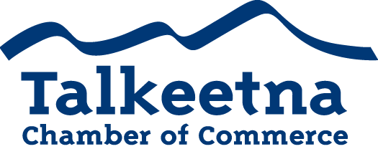

Board Meeting Agenda
February, 11 2020
Talkeetna Library

Call to Order: 12:05

Administrative Items:
- Board members in Attendance: Bill Rodwell, Lauren Kane, Critter Byrd, Casey Ressler, on phone Joe Mathis
- Others in Attendance: Shawn Standley, Whitney Wolf
- Time Keeper/Minute Taker: Bill Rodwell

Approval of Minutes:
- December, January meeting minutes: Casey made motion Critter second that we approve December and January minutes- all voted in favor

Treasurer’s Report:
- $17,902 in Checking
- $2,815 in Live at 5
- $4,267.23 in Money Market
- $1,605 in Scholarship
- $27.10 in Savings
- $106 in Gaming Checking ($81 in funds and $25 in minimum balance)
- $25 in Gaming Savings
- $4,447 in accounts receivable

Persons to be Heard:

Shawn Standley Denali Brewing Company

State of AK opening for public comment a regulatory proposal to limit multiple manufacturing license holders to limit the number of drinks served to an individual to 3 per day. Multiple license holders hold two or more brewery manufacturing license, winery manufacturing license and distillery license. DBC is a multiple license holder. DBC asks Chamber for a letter in opposition to this amendment. Suggested language from DBC: The Talkeetna Chamber of Commerce would like to voice opposition to amendment AAC304.475. We believe it would be detrimental to our community by negatively impacting the livelihoods of chamber members and their families and discouraging commerce. DBC 25-30 employees, impact to staff. DBC 10+ years as good operator, no violations.

Critter moved that we write a letter in opposition to this amendment. Casey seconded. All board members voted to yes.

Whitney Wolf Comsat Quarry Committee

Working with DNR to resolve issues. 3 land use areas surround this quarry. Ask that we write a letter to ask for reclassification of the quarry so as to include it in public process when need to use. Also include in the language that we support a management plan of the quarry.

Casey moved that we write a letter of support for responsible management plan. Critter second, all voted in favor.

Old Business:
- Taste of Talkeetna: Sold 9 less tickets than last year. Will work with restaurant owners to revamp the event next year.

Additions to Agenda:
- Fire department has asked for a letter of support for increase of mil rate

https://ktna.org/2020/01/talkeetna-fire-department-to-seek-mill-rate-increase/

Fire chief Eric Chappel will come to General meeting Thursday to present this.
- DNR quarry on Comsat: Moratorium has been put in place to hold off on permitting.
- Hindsight 2020 event Talkeetna Historical Society, KTNA, Chamber:
  - Based on 1999’s idea of what 2020 would look like- create an event called Vision 2020.
  - Perhaps we could create an event this year to recap what did happen and what it’s like today, and what it looked like then.
- New board member is Mabel and Vice President position to be determined.

Committees:

Bill suggested that we have work to do and we have a board retreat- will send out email to see who can make it and when- the sooner the better- perhaps end of Feb.

Lauren suggested that we get the chamber calendar up to date.
- Economic Development, Beautification, and Community Relations Committee: Bill has begun a discussion with a few other non-profits in the area about bathroom and trash solutions for summer 2020.
- Membership Committee:
- Marketing and Tourism Committee
- Finance Committee-pull tabs? Live at five, other fundraising needs?

Membership and Community Relations

Upcoming Meetings & Announcements: March 10 board meeting and March 12 general meeting

Meeting adjourned at: 1:45

