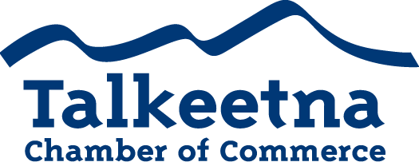

General Meeting Agenda
October 10th, 11 am
Flying Squirrel Bakery

Call to Order: 11:05
Administrative Items:
- Board members in Attendance: Bryann Zweifel, Mabel Quilliam, Lauren Kane
- Others in Attendance: Justin Savidis with Snowhook Adventure Guides of AK, Denise Richardson from MVFCU, Natalie Paris from Three Rivers Bookkeeping, DeAnn Autry from McKinley View Real Estate, Jane Bond from Talkeetna Majestic, Ron Quilliam from Denali Overlook, Kathy Watkins from CERT
- Time Keeper/Minute Taker: Bryann Zweifel
Treasurer’s Report:
- $10,819.14 in Checking
- $2,815 in Live at 5 (for next year)
- $2,740.21 in Money Market
- $35 in Scholarship
- $200 in Fire Hydrant
  - Move to scholarship fund…?
  - Motion by Bill
  - Seconded by Mabel
  - All voted in favor
- $27.10 in Savings
- $25 in Gaming Checking and Savings

Persons to be Heard:
- Kathy Watkins: CERT
  - Community Emergency Response Team
  - How to be prepared during a disaster so that you can help your neighbor
  - Free to join, with a 20 hour training course in November in Willow (2 Saturday’s and 2 Sunday’s)
  - Importance of Businesses having a plan should an emergency/disaster occur
    - Power outage during summer time
    - Flood
    - How to react towards customers during these events
Old Business:
- Pull tabs: reach out to Talkeetna Inn/Fairview/VFW
- Preparations for the annual banquet are coming along
- Bylaws: non-profits are currently unable to serve on the board or vote
  - Amend to combine Associate and Active memberships so all members can retain voting rights.
    - Bill made a motion to amend the bylaws
    - Mabel seconded
    - All were in favor
Additions to Agenda: Pledge of Allegiance recited after meeting started
Committee Reports:
- Beautification and Community Relations Committee
- Marketing and Tourism Committee
  - Justin Savidis from Snowhook Adventure Guides of AK would like to be on this committee
- Finance Committee
  - Working on budget

Membership and Community Relations
- Discussion on a winter list of businesses that are open
- Winter Activities
- Possibility of having a seminar regarding financial wellness/planning/payroll/finance
  - Bryann and Natalie would head this
- Possible conference with tour operators, B&B’s local businesses regarding non-profit best practices
- Discussion about Live at 5, sponsors, what is the role for the Chamber
- Discussion on Visitors Guide, where are they placed throughout the state

Upcoming Meetings & Announcements
- October 25th Annual Banquet
- Next General meeting 11/14/19 location TBD
- December 6th Parade of Lights and tree lighting
- December 14th Taste of Talkeetna
  - Raffle tickets to be presented to members at Nov meeting with raffle being given away on December 14th.
    - Still obtaining raffle prizes

