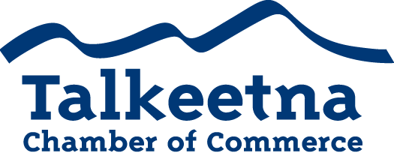

Board Meeting Agenda
May 9th, 2019
West Rib Pub & Grill

Call to Order: 11:04
Administrative Items:
- Board members in Attendance: Bryann Hanks, Bill Rodwell, Casey Ressler, Lauren Kane, Mabel Quilliam
- Others in Attendance: Jim Henderson
- Time Keeper/Minute Taker: Katie Gilligan
Approval of Minutes:
- April meeting minutes as written: Approved
Treasurer’s Report:
- $4,551 in Checking
- $815 in Live at 5 (for next year)
- $2,736 in Money Market
- $1,535 in Scholarship (about to disperse)
- $200 in Fire Hydrant (old project)
- $27.06 in Savings
- $25 in Gaming Checking and Savings
- $8,001 in accounts receivable
Persons to be Heard:
Old Business:

Additions to Agenda:
- Date for September meeting: September 12th
- Date for annual banquet: October 25th
  - Send emails to Shawn, Jerome, and Anita for banquet quotes for around 50 people (plus space).
  - Finalize gaming permit: motion passed
  - Rasmussen Foundation monies available for our Scholarship fund?
  - Walmart grant for Scholarship?
Committee Reports:
- Economic Development Committee

- Marketing and Tourism Committee

- Membership and Community Relations Committee

Membership and Community Relations

- Talkeetna Sewer and Water
  - The sewer and water tax ordinance change recently passed, removing the 3% sales tax from utilities.
- DAC
  - Gearing up for Live at 5

Upcoming Meetings & Announcements
- Summertime! Woohoo!

