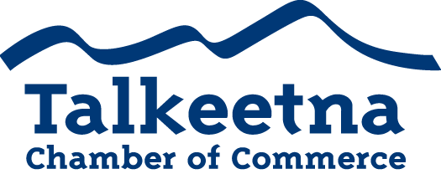

General Meeting Agenda
April 11th, 2019
Talkeetna Historical Society

Call to Order: 12:20

Administrative Items:
- Board members in Attendance: Bryann Hanks, Bill Rodwell, Lauren Kane, Mabel Quilliam, Niina Baum, Casey Ressler
- Others in Attendance: Trisha Costello, Sue Deyoe, Denise Richardson, Ron Quilliam, Corinne Smith, Jake Graupmann, Joellen Bye
- Time Keeper/Minute Taker: Katie Gilligan
Approval of Minutes:
- March meeting minutes as written: Approved
Treasurer’s Report:
- $12,506.37 in Checking
- $8,515 in Live at 5
- $8,736.74 in Money Market
- $1,535 in Scholarship
- $200 in Fire Hydrant (old project)
- $27.06 in Savings
- $25 in Gaming Checking and Savings
- $17,148 in accounts receivable
Persons to be Heard:
- Sue Deyoe gave a presentation on the history of Talkeetna, as well as the Historical Society’s mission and role within the community.
- Corrine Smith spoke about KTNA and its role as a non-profit and how they’re being affected by state budget cuts.
- Mabel Quilliam spoke about the Homemaker’s Association CERT emergency preparedness class, as well as their scholarship fund.
- Ron Quilliam spoke about the fire department and their goal to install smoke alarms in the community.

Old Business:

Additions to Agenda:

Committee Reports:
- Economic Development Committee

- Marketing and Tourism Committee
  - Sportsmans Show
    - Katie Gilligan and Jake Graupmann set up and manned the booth Thursday
    - David Hicks manned the booth Friday
    - Katie Gilligan and Niina Baum manned the booth Saturday
    - Beth Valentine and Mike Matthews manned the booth Sunday and transported the supplies back home.
  - Visitors Guide:
    - $22,000 in ad sales
    - Finalizing printing, distribution, etc.
  - Live at 5
    - Within $500 of our goal
  - Scholarship fund
    - Board voted to allocate three $500 scholarships

- Membership and Community Relations Committee

Membership and Community Relations

- Talkeetna Sewer and Water
  - There will be a sewer and water tax ordinance change up for vote at the MSB assembly meeting May 2nd at the Willow Community Center at 6 pm, free dinner at 5 pm.
The ordinance would make residential utilities exempt from taxation. You can attend in person and/or submit the attached form if you would like to be heard.
- DAC
  - Gearing up for Live at 5

Upcoming Meetings & Announcements

