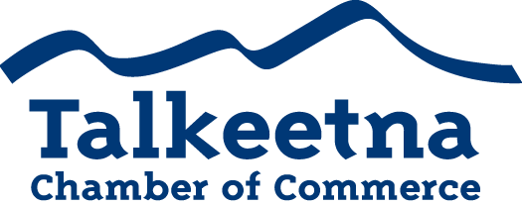

General Meeting Agenda
March 14th 12:00 pm
Flying Squirrel Bakery

Call to Order: 12:00 pm
Administrative Items:
- Board members in Attendance: Bryann Hanks, Lauren Kane, Mabel Quilliam, Bill Rodwell, Niina Baum, Joe Mathis
- Others in Attendance: Ember and Christian Haynes, David Hicks, Margaret Adsit, Corinne Smith, Phillip Manning, Robert and Marne Sheldon, Anna Woehrle, Jenny Krepel, Dora Redman, Hilary Fisher and 2 guests, Jodi Rodwell, Jillian Simpson, Jok Bondurant, Cynthia, Denise Richardson, Sue Deyoe, Kathleen Flemming, Anita Golton, Ron Quilliam
- Time Keeper/Minute Taker: Katie Gilligan
Treasurer’s Report:
- $5,411.92 in Checking
- $5,265 in Live at 5
- $8,736.74 in Money Market
- $1,535 in Scholarship (received a few donations recently)
- $200 in Fire Hydrant (old project)
- $27.06 in Savings
- $25 in Gaming Checking and Savings
- $5,787 in accounts receivable
Persons to be Heard:
- Guest Speaker Jillian Simpson with ATIA
Old Business:
Additions to Agenda:
- Public Notice of ARRC Proposal to lease 8.31 acres along Talkeetna River
  - Robert and Marne Sheldon spoke about their application to lease the property.
  - They have asked us to write a letter of support.
  - The Chamber members present voted to recommend the board write a letter of support.
  - The board voted in support of writing a letter of support to Nordly’s pledge to continue to give community access to the area and closely follow the usage guidelines of the Talkeetna Riverfront Management Plan.
- Live at 5
  - Sponsorship sheets will be sent out next week, hopefully.
- Visitor’s Guide
  - Advertising rates will be sent out next week so that printing can commence and guides can be ready by May 1st.
Committee Reports:
- Economic Development Committee
  - Meeting report submitted by Niina

- Marketing and Tourism Committee

- Membership and Community Relations Committee

Membership and Community Relations

- Talkeetna Sewer and Water

- DAC
  - Looking for a new director

- NSI
  - Also may be looking for a new director

- TCCI
  - Has submitted a request for comment extension regarding Public Notice of ARRC Proposal to lease 8.31 acres along Talkeetna River.

Upcoming Meetings & Announcements
- April 11th Meeting: Non-profit Round Up
  - Sue Deyoe with the Talkeetna Historical Society has offered to host and give a brief presentation.
- May 9th: Member Sound Off
  - Meeting potentially at the senior center

