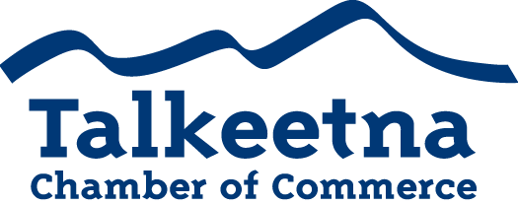

Board Meeting Agenda
January 8th, 2019 – 11:00 am
The Swiss Alaska Inn

Call to Order:
Administrative Items:
- Board members in Attendance:
- Others in Attendance:
- Time Keeper/Minute Taker: Katie Gilligan
Additions to Agenda:
Approval of Minutes:
- December meeting minutes as written:
Treasurer’s Report:
- $12,402.05 in Checking (need to pay out Taste of Talkeetna, actual working funds sit at $7,702.05)
- $5,265 in Live at 5
- $8,731.41 in Money Market
- $1,470 in Scholarship
- $200 in Fire Hydrant (old project)
- $27.06 in Savings
- $25 in Gaming Checking and Savings
- $9,396 in accounts receivable
Persons to be Heard: None
Correspondence:
Committee Reports:
- Taste of Talkeetna
  - Cut checks and mail to businesses

- Visitor’s Guide
  - Will want to have printed by January. This month is the month to work on them.
  - Casey and Katie on the committee

- Scholarship/General Fundraising Committee
  - Need to get the ball rolling on scholarship fundraising and a committee. Ideas?

- General Meeting Attendance Committee
  - Joe, Bryann, Lauren

Membership and Community Relations

- TCCI Report:

- Talkeetna Water/Sewer Board Report: None

Old Business:
- Gaming account

Upcoming Meetings & Announcements

