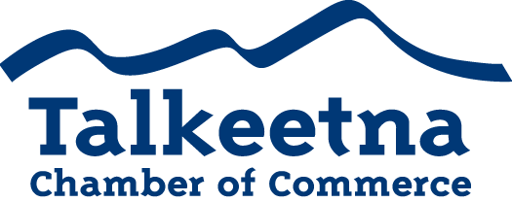
General Meeting Agenda
December 6th, 2018 – 12:00 PM
Denali Brewpub

Call to Order: 12:13
Administrative Items:
- Members in Attendance: Bill, Lauren, Mabel. No quorum.
- Others in Attendance: Audrey Ebner, Jenny Krepel, Corrinne Smith, Denise Richardson, Ron Quilliam, Jane Steere, Mrs. Pijuan
- Time Keeper/Minute Taker: Katie Gilligan
Additions to Agenda:
- Strengthening relations with Talkeetna Community Council
  - Think about sending a Chamber board member to Council meetings, suggest someone from the Council come to Chamber meetings.
  - Maybe the Chamber board could sit down with Council board? Council meetings are at the public library at 7 pm on the first Monday of the month.
- Find out if we need permitting for the park for Live at Five and other park events.
  - More than one permit or shared permitting?
  - If so, should non-profits have to pay for permitting?
- Communication with members: currently social media, website, email.
  - Members suggest adding links in newsletters
- Make sure people sign parade waivers for the next Parade of Lights
- DAC bathrooms for 2019
  - Keep in touch with the DAC

Treasurer’s Report:
- $3,172.17 in Checking
- $5,265 in Live at 5
- $8,716.94 in Money Market
- $1,470 in Scholarship
- $200 in Fire Hydrant (old project)
- $27.06 in Savings
- $25 in Gaming Checking and Savings
- $11,496 in accounts receivable

Persons to be Heard (recommended 5 minutes)
Committee Reports:
- Taste of Talkeetna
  - Katie, Rick, Casey chairing
  - Everything is set for Saturday, though ticket sales are low.
  - Next year try Frontiersman, ADN, Alaska Railroad, packages rolled up with the Roadhouse, etc. to increase sales.
  - Look into transportation (taxi, shuttle, etc.) during the event to encourage attendance.
- General Meeting Attendance Committee created
  - Bryann, Joe, and Lauren are chairing.
  - Will focus on improving our GM meeting member attendance and structure to be more helpful to our members.
- Fundraising/Scholarship Committee
  - Needs members
- Visitor’s Guide Committee
  - Casey and Katie chairing
  - Will begin once Taste of Talkeetna is finished
  - Expand the town map to Comsat?
  - Expand area/Spur map further?
  - Don’t list a date/year on the front
  - Potentially list date on the back cover at the bottom just for reference.
  - Don’t double ad cost but do 150%- buy 2019 get 2020 half off, more or less?
- Potentially vote to having the following committees: an Events Committee (for Parade of Lights, Taste of Talkeetna, etc), a Fundraising Committee (for Live at Five, Scholarship, etc), an Attendance Committee, and a Visitor’s Guide/Advertising/Media committee.
- Use Rick as contact for bus/train info/arrival.

2018-2019 Upcoming Events and Dates
- Taste of Talkeetna December 8th, 2018
- Moose on Parade 2019
  - Future of MOP is doubtful. Fundraising suggestions welcome.

Old Business:

New Business:

Upcoming Meetings & Announcements
- January 8th: Board Meeting 11:00 AM Swiss AK Inn
- January 10th: General Meeting 12:00 PM West Rib Pub

Bryann, Joe, Niina, and Casey absent.

