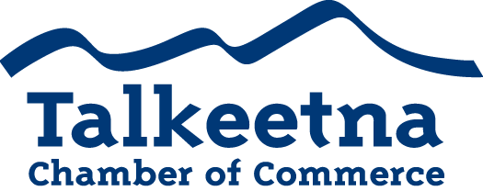

Board + General Meeting Agenda
February 14th 11:00 am
North Shore Cyclery

Call to Order:
Administrative Items:
- Board members in Attendance:
- Others in Attendance:
- Time Keeper/Minute Taker: Katie Gilligan
Approval of Minutes:
- January meeting minutes as written:
Treasurer’s Report:
- $4,779.82 in Checking
- $5,265 in Live at 5
- $8,736.74 in Money Market
- $1,470 in Scholarship
- $200 in Fire Hydrant (old project)
- $27.06 in Savings
- $25 in Gaming Checking and Savings
- $8,096 in accounts receivable

Persons to be Heard:
- Lynn Gattis with the State of Alaska Governor’s office
- Rigoberto Gonzalez-Nossa with the U.S. Small Business Administration
- Sam Ivey with the Alaska Department of Fish and Game (guest speaker)
Old Business (in conjunction with today’s agenda below)
- Helping to raise funds for the TCCI Recycling Committee.
- Donation to Alaska Airmen’s Association for the Talkeetna Fly In
- Sign and submit the last of the paperwork for our liability insurance
- Katie working with Anita Golton from the Recycling Committee to create a webpage on the Chamber’s site.

Additions to Agenda:
- Create a letter to Chamber members regarding the TCCI’s insurance needs for Talkeetna Recycling Works.
- Vote on the Talkeetna Fly-In donation amount and our role in the treasure hunt.
- Talkeetna Rendezvous was held Feb 5th
- Visitor’s Guide: See committee report below
- Live at 5: Need to raise funds and apply for permitting.
- Scholarship fund:

Committee Reports:
- Economic Development Committee
  - Winter tourism ideas?

- Marketing and Tourism Committee
  - Visitor’s Guide: John Woodbury is swamped; printing will be delayed until spring. Katie and Casey keeping tabs on progress.
  - Katie has been working to amp up our social media presence through Facebook and newsletters.
  - We’ve mailed out hundreds of guides the last few weeks!

- Membership and Community Relations Committee
  - Need to get the ball rolling on the scholarship fund. We only have a few months to fundraise, set up requirements, allow students to apply, review the applications, interview candidates, and disperse funds.

Membership and Community Relations

- Talkeetna Sewer and Water
  - Working to remove taxes from local utilities
  - Working with the state and borough to finalize a loan to fix the sewer and water system.

- DAC
  - Looking for a new director

- NSI
  - Also may be looking for a new director

Upcoming Meetings & Announcements
- March meeting:

