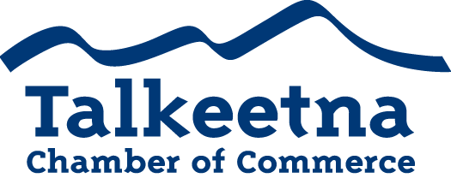

Board Meeting Agenda
December 4th, 2018 – 11:00 am
Talkeetna Roadhouse

Call to Order: 11:09
Administrative Items:
- Board members in Attendance: Casey, Mabel, Bill, Bryann (via phone)
- Others in Attendance: None
- Time Keeper/Minute Taker: Katie Gilligan
Additions to Agenda:
- Casey Ressler- ATIA infrastructure projects
  - Tourism infrastructure projects needing funding
  - Is there a Talkeetna project we’d like to include? We would need to submit before December 14th.
  - We probably don’t have time this year, but can mull over potential projects for next year.
Approval of Minutes:
- November Meeting minutes as written: approved
Treasurer’s Report:
- $4,182.17 in Checking
- $5,265 in Live at 5
- $8,716.94 in Money Market
- $1,470 in Scholarship
- $200 in Fire Hydrant (old project)
- $27.06 in Savings
- $25 in Gaming Checking and Savings
- $11,496 in accounts receivable
Persons to be Heard: None
Correspondence: Recycling sign- Troy Smiley
- Approved to use the image of the Beautiful Downtown Talkeetna sign for a sign at the transfer site for recycling. Future use beyond a sign will need to be approved.
Committee Reports:
- Taste of Talkeetna
  - Katie created a poster
  - Casey had the posters printed, drove them up
  - Rick printed tickets and dropped them off at the Roadhouse
  - Katie distributed the posters, created social media announcements, radio announcements, a newsletter, etc.
  - Everything should be set for this Saturday.
  - Boost a Facebook ad, email restaurant owners to increase ticket prices.
  - Next year explore other advertising avenues. ADN, Frontiersman, etc. to increase attendance. Will ask members at General Meeting for other suggestions.

- Winterfest- Parade of Lights and Tree Lighting
  - Went well. Next year have people sign waivers.

- Visitor’s Guide
  - Will want to have printed by January. This month is the month to work on them.
  - Casey and Katie on the committee
  - Katie to create a spreadsheet of visitor’s guide profits/expenditures
  - E-mail John for printing costs, distribution costs with Anchorage Brochure

- Scholarship/General Fundraising Committee
  - Need to get the ball rolling on scholarship fundraising and a committee. Ideas?

- General Meeting Attendance Committee
  - Joe, Bryann, Lauren

Membership and Community Relations

- TCCI Report: Neighborhood watch funding has been secured for the Talkeetna area. Contact TCCI if you’d like to join or get more info.

- Talkeetna Water/Sewer Board Report: None

Old Business:
- Website:
  - Katie met with Webdogs and now has the ability to reset passwords and logins for members, without going through Webdogs.
  - Members can now submit their own events to the Chamber website.
  - Ticket sales: in the future, we may want this ability.
  - We can either pay Webdogs to create a plugin which sells tickets directly through our website (around $2,000) or…
  - Use Eventbrite. This service would create a link we can post on our website, and they only charge processing fees.
  - Could Webdogs rotate listings for lodgings so the same rentals aren’t at the top/bottom?
- New signers for bank account
- Gaming account

New Business:
- IRS penalty

Upcoming Meetings & Announcements

January 8th, 2019- Board Meeting 11:00 AM at The Swiss AK Inn
January 10th, 2019- General Meeting 12:00 PM at The West Rib Pub

End 12:32

Niina, Joe, and Lauren absent.

